TV18/924 Vroem, vroem

Vroeger had je Speedy Gonzales

snel, sneller, snelst in Looney Tunes

rood sjaaltje, gele sombrero.



*"¡Ándale! ¡Ándale! ¡Arriba! ¡Arriba!"* (Schiet op, ik kom eraan!).

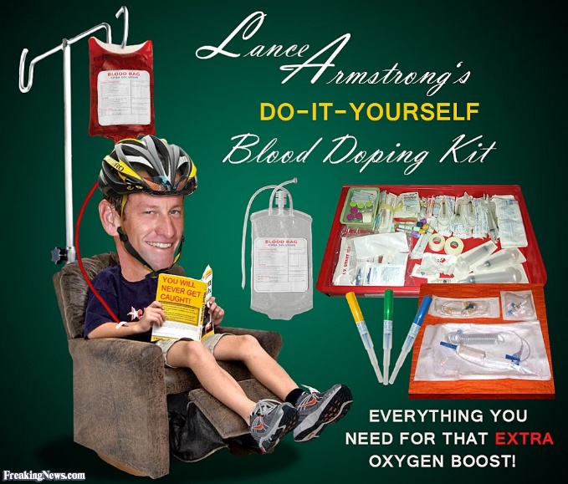

Bij het wielrennen had je Lance

1x, 2x,..., 7x op z’n best in de Tour

bloed en doping, gele trui.

*"¡Ándale! ¡Ándale! ¡Arriba! ¡Arriba!".*

Nu heb je al jaren een renner bij Sky

pufjes tot wel 32x in een etappe

de ene dag gelost, de dag erop top.

Froome, Froome,

*"¡Ándale! ¡Ándale! ¡Arriba! ¡Arriba!".*

Vroem, Vroem, ....

Dan heb je de controle bij het UCI

bewijslast al 4 maanden en nog 3

astma als excuus, geen recht op geel!

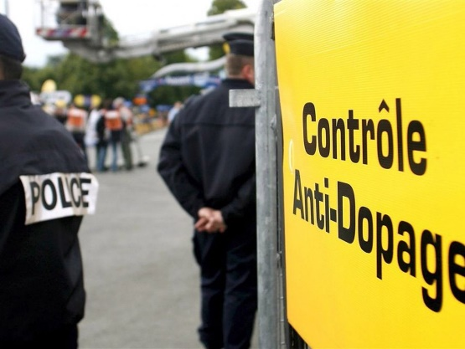[](https://www.bing.com/images/search?view=detailV2&ccid=R3zEBDZq&id=AB5A8B1273301F3A8A36F34DCCC83C2D278DC08E&thid=OIP.R3zEBDZqdotDSB5YoUrY-gEsEp&q=doping+UCI&simid=608016205527976426&selectedIndex=234)

Vroem, vroem,

*"¡Ándale! ¡Ándale! ¡Arriba! ¡Arriba!",*

maar niet te snel.

21-1-2018

[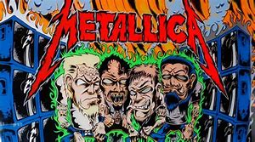](https://www.bing.com/images/search?view=detailV2&ccid=XkASnLQx&id=4D7770266CD0ABF064C52397D5CDF2BA1FE131C0&thid=OIP.XkASnLQxCdbYdgWhdQA-9wHaEI&q=sad+but+true+metallica&simid=608003732913718985&selectedIndex=80)

|  |  |
| --- | --- |
| Hey (hey) I'm your life I'm the one who takes you there Hey (hey) I'm your life I'm the one who cares They (they) They betray I'm your only true friend now They (they) They'll betray I'm forever there  I'm your dream, make you real I'm your eyes when you must steal I'm your pain when you can't feel Sad but true  I'm your dream, mind astray I'm your eyes while you're away I'm your pain while you repay You know it's sad but true Sad but true  You (you) You're my mask You're my cover, my shelter You (you) You're my mask You're the one who's blamed Do (do) Do my work Do my dirty work, scapegoat Do (do) Do my deeds For you're the one who's shamed  I'm your dream, make you real I'm your eyes when you must steal I'm your pain when you can't feel Sad but true  I'm your dream, mind astray I'm your eyes while you're away I'm your pain while you repay You know it's sad but true Sad but true | I'm your dream  I'm your eyes  I'm your pain   I'm your dream (I'm your dream) I'm your eyes (I'm your eyes) I'm your pain (I'm your pain) You know it's sad but true  Hate (hate) I'm your hate I'm your hate when you want love Pay (pay) Pay the price Pay, for nothing's fair  Hey (hey) I'm your life I'm the one who took you there Hey (hey) I'm your life And I no longer care  I'm your dream, make you real I'm your eyes when you must steal I'm your pain when you can't feel Sad but true  I'm your truth, telling lies I'm your reason, alibis I'm inside, open your eyes I'm you  Sad but true    <https://www.youtube.com/watch?v=A8MO7fkZc5o> |